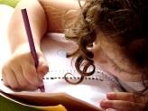  Literacy  In our talk 4 writing this half-term we will be looking at ‘warning stories’. We will be reading The Caravan’ and looking at how authors use figurative language to describe settings and characters.  Later in the term, we will move onto studying balanced arguments and have discussions in class by identifying fact and opinion. We will continue to improve our joined handwriting focusing on improving our vocabulary, sentence structure and our use of brackets and dashes in our writing. | 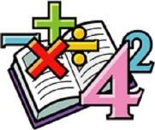  Maths  In maths this half term we will be recapo9ng our formal methods of multiplication and division. Leading to developing our understanding of fractions, by simplifying, adding, multiplying and finding quantities of numbers.  We will continue to improve our times tables and arithmetic skills. |  | 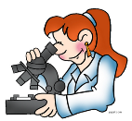  Science  In Science this half-term we will be continuing to look at light. We will be carrying out our own experiments around shadows and refraction to help us further understand how light travels. We will also be focussing on recording our results and reporting our findings. | 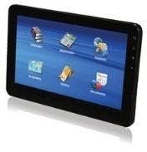  Computing  In computing this half-term, we will be looking at ‘Data Handling’. We will learn about how computers use the world web web to provide services and how networks use QR codes to collect and store data. Later in the unit we identify how infra-red and RFID is used to collect and record data.
Humanities  Thinking about what we know about our Earth, we are going to identify the countries of North America. We will have the opportunity to identify longitude and latitude, time zones and compare these with the UK. Also we will be identifying geographical similarities and differences between a region of UK and a contrasting region of North America – Yorkshire and Alaska. | Autumn 2 - Year 6 Curriculum Web  Our class book  Orphans of the Tide by Straun Murray  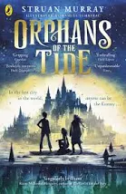 |  |  | RSHE  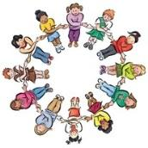  In RSHE this half term we will be looking at how we can keep healthy as we grow. We will look at different forms of relaxation and mindfulness, thinking about how we can work towards achieving a goal. We will look at how technology can impact our health and what strategies we can use to help us through creating good habitats.
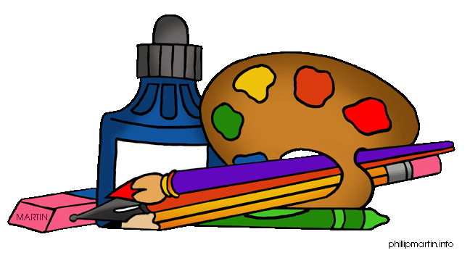  Art and DT  In DT this half-term we are going to be making our own waistcoats. Children will have the opportunity to research, design, make and evaluate their own product. We will use a running stitch to stitch our garment together and look at fastening decorations. | 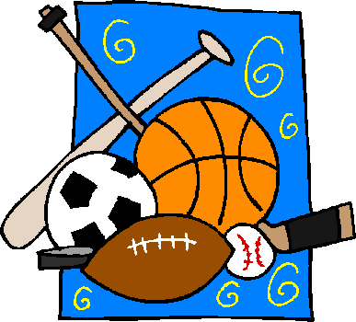  PE  In PE this half-term we will be improving our invasion game skills through hockey. We will learn the key skills of passing, dribbling, attacking and defending. We are also continuing our swimming lessons and the indoor swimming pool through learning a range of strokes and understanding water safety. | Music  In music this half-term will be listening to and understanding a wide range of high-quality music drawn from from great composers. From this we will be developing melodies using rhythmic variation, transposition and changes in dynamics, pitch and texture to create group compositions. |  | RE  In RE this half-term we will be looking at what different religions say when life gets hard and also different beliefs on life and death. Children will explain some similarities and differences between beliefs about life after death and why Christians and Humanists have different ideas about an afterlife.

